

Internal Procedures

Section XX
Control & Automation
LV Operations Manual

This document is uncontrolled when printed. Please refer to Sharepoint for the latest version.

VERSION
DATE
AUTHOR
REVIEWED BY
APPROVED BY
NEXT REVIEW DATE
REF/VERSION
DATE
AUTHOR
REVIEWED BY
APPROVED BY
NEXT REVIEW DATE

02-06-04-01/1.0

Contents
Introduction 2
Purpose and Scope 3
Definitions 3
Health, Safety, & Environmental Considerations 4
Risk Assessments 4
Responsibilities 5
Inputs 6
LV Design & Engineering 6
LV Manufacturing 11
LV Testing 17
Operational Inspection & Maintenance Manuals 22
Outputs 23
Referenced Processes and Forms 24
Appendices 25

Introduction
Our procedures exist for a reason. They protect our standards, our people and our reputation. At COMPANY NAME, following procedures isn’t about bureaucracy - it’s about delivering quality work with consistency and discipline. It reflects the pride we take in doing the job properly, the responsibility we have to our customers and colleagues and our commitment to continuous improvement.
Clear processes help us manage risk early, communicate effectively and ensure that no detail is overlooked. They create fairness, accountability and a shared way of working across the Group. Most importantly, they allow us to operate safely, professionally and profitably.
Everyone at COMPANY NAME is trusted to apply judgement within the framework we provide but that trust comes with the expectation that procedures are understood, followed and upheld. Doing so protects what makes us strong today and supports our progress for the future.

Purpose and Scope

This comprehensive manual details the end-to-end process for Low Voltage (LV) assemblies. Specifically, it:
Defines LV design engineering requirements for creating project-specific LV design and engineering documents that meet customer requirements, so new LV equipment can be manufactured or existing equipment modified to meet project LV scope.
Defines manufacturing requirements and best‑practice processes for LV assemblies and LV equipment, aligned with customer and project scope requirements.
Defines testing requirements and best‑practice processes for LV assemblies and LV equipment, again aligned with customer and project scope requirements.
Provides guidance on producing a consistent-quality OIM manual.

Definitions
- LV Design
Particular electrical design required to fulfill the deliverables as described in design documentation provided, amounting to the provision of new electrical equipment (e.g. an LV Assembly) or modification to existing electrical equipment (not provided), installed as part of an overall electrical system.
- LV Assembly
A combination of one or more low-voltage switching devices together with associated control, measuring, signalling, protective, regulating equipment, with all the internal electrical and mechanical interconnections and structural parts as defined by the original manufacturer, which can be assembled in accordance with the original manufacturer’s instructions.

- LV Design Drawing
A drawing produced using in-house computer-aided design (CAD) software to provide information for manufacturing or installing electrical equipment, preparing electrical wiring or non-electrical connections, or supplying loose equipment to be used as part of an electrical system or communications network.
Examples of these drawings include, but are not limited to:
- Two-dimensional and three-dimensional diagrams (2D / 3D) showing metal and non-metal enclosures and their parts, such as doors, mounting plates, covers, and internal compartments.

Examples include general arrangement diagrams, door cut-out diagrams, and mounting plate equipment layout diagrams for new LV assemblies, as well as changes or extensions to existing LV assemblies.

- Schematic wiring diagrams or electrical wiring diagrams for power, control, indication, and interface circuits. These drawings give detailed connection requirements for electrical equipment so it can perform the required function within an LV assembly, a modified LV assembly, or another part of an electrical system.

For example, a motor-starter wiring diagram gives the information needed to manufacture the power, protection, control, indication, and system interface parts that make up a functional unit within an LV motor control centre.

Health, Safety, & Environmental Considerations
The design, manufacturing and testing process for LV Assemblies shall refer to the principles outlined in COMPANY NAME Health & Safety Policy, Environment Policy and Sustainability Policy to ensure impacts are considered and minimised, for example:
- Ensuring equipment is accessable and at a suitable level
- Correct spacing and fitting of equipment within LV Assemblies
- Business operations – e.g. procurement of materials from local suppliers, consolodated deliveries
- Embodied carbon of products – e.g. low carbon alternatives
- Operational emissions of products – e.g. energy efficiency
- Waste management and circular economy – e.g. reuse of materials
- Reducing energy consumption through manufacturing techniques
- Use of recycled materials (Trunking and Din Rail)
- Reduction of carbon emissions
- Use of recycled materials

Where possible, the EPLAN CAD software may include embodied carbon values of specified components to enable the carbon impact of a design to be assessed. This highlights carbon hotspots and opportunities to seek low carbon alternatives where possible.
NOTE: These considerations are evaluated at a strategic level and not intended to be evaluated at a product level, unless specifically required by the client.

Risk Assessments
A Design Risk Assesseemnt should be completed for every project, to ensure any hazards identified have a comprehensive review and a understanding of the equipment which is being designed and manufactured. Each of the identified hazards is to be assessed and recorded using the correct form.
An worked example of this is done is described in Appendix xx
A Manufacturing & Testing Risk Assesseemnt should be available and updated regularly and communicated to the production team, to ensure any hazards identified have a comprehensive review and a understanding of the operations and equipment which is being manufactured and tested. Typical identfied hazards to be considered include;
• Electrical hazards
• Mechanical hazards
Each of the identified hazards is to be assessed and recorded using the correct form.
An worked example of this is done is described in Appendix xx
The hazard and the associated risk reduction measure is to be is to be detailed against a specific hazard. A numeric score is to be entered for the associated severity and probability in order to determine a risk score.
Firstly a severity score (1 to 5) is determined based on the impact of the hazard. Secondly a probability score (1 to 5) is determind based on the the likelihood of the hazard occurring. The risk score is then determined by multiplying both the severity score and the probababilty score together and recorded in the correspomnding column of the table.
Risk Reduction
All hazards having a risk score above 11 are to be either eliminated or have the risk reduced. Using one or more of the following four approaches to risk reduction:
- Safe Design & Operations - This is undoubtedly the most beneficial approach. The purpose is to have a design and operation free from hazards and risks to health and safety by careful planning.
- Protection measures - Reduction of the risk by employing suitable guards, barriers and protection devices within the equipment.
- Information - Minimising the residual risk by informing colleugues and vistors. This could be labelling, instruction warnings etc.
- Additional precautions - Provision of additional safety measures above the normal personal protection equipment to enhance the safety of the equipemnt and its operation.

If the risk remains above 11 after risk reduction measures, then the hazard is to be referred to the LV Operations Director.
Record of Risk Assessment
The Design Risk Assesseemnt should be available within the proejct file and shared with the client. Prior to any Manufaturing or testing, the Design Risk Assessment must be reviewed to ensure the risks have been captured and mitigated.
The Manufacturing Risk Assesseemnt should be available within the Manufacturing area, ready available for all employees and visitors. Prior to anyone new entering the Manufaturiong facility, the Risk Assessment must be read and understood, with a signed record of the individual acknowledging the risks within the facility.

Responsibilities
- LV Engineering Manager
- LV Design Engineer
- LV CAD Technicians
- LV Production Manager

Inputs
- BS EN 61439-1:2011 Low-voltage switchgear and controlgear assemblies: General Rules
- BS EN 61439-2:2011 Power switchgear and controlgear assemblies
- The Electrical Equipment (Safety) Regulations 2016
- The Electromagnetic compatibility regulations 2016
- Low-voltage directive 2014/35/EU
- Electromagnetic compatibility directive 2014/30/EU
- User Requirements Specification (URS) \ Functional Design Specification (FDS) \ Control Philosophies
- Client design documents (E.g. SLD, Motor & Load Schedules, Instrument & Valve Schedules)
- Environmental considerations including lifecycle perspective
- Clarifications to Technical Queries (Where required)
- LV Issue Log

LV Design & Engineering
LV assemblies manufactured by COMPANY NAME shall be designed and manufactured to comply with the requirements of the product standard, BS EN 61439-2. This procedure refers to those assemblies. Any manufactured equipment outside of the scope of this product standard must be referred to the Operations Director relating to their conformity marking requirements, if any.
Design Input
The allocated LV Design Engineer shall request ‘For construction’ issue design documentation from the client and it shall be determined what design deliverables are required. For example a User Requirements Specification, Functional Design Specification or other scope document/s shall be available from the client, along with all other relevant design documentation (e.g. Design schedules detailing the equipment to be incorporated as part of the electrical design, e.g. SLD \ motor \ valve \ instrument schedules etc.). This documentation should be reviewed to ensure that the design deliverables of the project are fully understood. Preparation of the design deliverables will commence as soon as practical and submitted to the client for review \ comment. During the design process, any technical queries and any quality related issues encountered are to be detailed on the LV Issue Log.
Note: Where any clarification is required, this shall be addressed with the client’s representative and documented records maintained via SharePoint, detailing any clarificatons received through the issue of Technical Queries.

Creation of LV Designs
LV Design drawings and documents may include general arrangement drawings, (e.g. 2D \ 3D diagrams) where an enclosure is required. In this case a general arrangement (GA) drawing shall be prepared to ensure the design requirements of the URS \ FDS \ Design schedules and any particular site specific constraints (e.g. physical limitations) are included. At this stage the GA drawing shall be submitted to the client for review \ comment to enable the electrical design to proceed. At the earliest opportunity the associated LV Assembly enclosure and any long-lead equipment identified, shall be procured.
Other LV Design drawings and documents may include Schematic Wiring Diagrams, (e.g. Motor-starter wiring diagrams, ICA wiring diagrams), and any associated technical calculations or reports as required, dependent on the nature of the LV design scope, which may require the manufacture of LV Assemblies and/or the on-site modifications to existing LV Assemblies or electrical equipment.
Creation of all LV Design Drawings shall primarily be undertaken using proprietary in-house CAD software under the control of COMPANY NAME. Standard COMPANY NAME drawing borders shall be utilised on all projects with the exception of any client’s specific requirements. LV Design Drawings shall be prepared using a standard and consistent format.
Drawing Creation (Drawn by)
LV CAD Technicians and LV Design Engineers, shall create and update CAD drawings which are intended for purposes of manufacturing \ delivering the LV Scope of a project as required. Where an LV CAD Technician has created the drawings for an LV Design Engineer, the drawings shall be reviewed by the responsible LV Design Engineer prior to any drawings being checked. The intitials of the person creating the drawing are to be included in the ‘Drawn By’ field.
Drawing Checking (Checked by)
Further to the initial review, drawings shall be checked by a nominated LV Design Engineer (As defined by the LV Engineering Manager). When the checks listed below have been completed, the ‘Checked by’ box should be initialled by the nominated LV Design Engineer.
Drawing checks;
- Drawings reflect the design information made available
- Drawing identification fileds are correctly completed
- Drawings are technically accurate and meet specification requirements
- Drawings are complete for the purpose of the issue status.
- The design meets all required COMPANY NAME standards and CAD requirements.
Important note: ‘Drawn by’ and ‘Checked by’ filed initials must not reference the same person.
Drawing Approval (Approved by)
The drawing shall be initialled as ‘Approved by’ after the following checks are satisfactorily completed:
- The drawing check procedure has been completed
- The Approver is satisfied that this procedure has been followed and that the drawing meets the acceptable criteria and is complete and correct for issue
- The Approver shall carry out limited spot checks on a selection of drawings and/or functional control circuits.

The LV Engineering Manager shall approve the drawings when the above checks have been completed. The checker and approver must be different people.
Drawing Issue
First Issue (Client review \ comment purposes)
Where drawings are submitted to the client, they shall be confirmed as having been checked and approved in line with the previous associated steps. The drawings shall be transmitted to the client with a Document Register / Transmittal Form issued for the intended purpose as defined on the form.
Note, the client may either be an external customer or an internal COMPANY NAME contact from the same or different division or business unit. In either case, it shall be determined which client (Internal or External), drawings will be issued to for the intended purpose.
Subsequent comments or requests for change by the client are reviewed and incorporated as appropriate with revision control until the intended purpose changes, e.g. issued into production.
Construction purposes:
All drawings (initialled & revised) issued into production shall be accompanied by an associated Document Register / Transmittal Form. The drawings and document register / transmittal form are to be clearly marked ‘Approved For Construction Only’. The issued registers is to be checked and signed by the LV Production Manager and retained in the Manufacturing Job Pack .
When issuing revised drawings, the changes are to be circled / boxed using a highlighter pen to clearly identify changes. A copy of the previous revision of the drawing marked ‘Superseded’ may accompany the revised drawing to reaffirm the changes.
The Document Register / Transmittal Form is checked to ensure receipt of all drawings and their revision status to ensure drawings are initialled as approved prior to issue into production.
Inspection and testing purposes:
For inpection and testng a ‘clean’ set of the ‘Approved For Construction’ drawings are to be issued.
As Tested
Upon completion of the manufacturing and testing phase, marked up changes to drawings are to be added to the CAD drawings for issue at ‘As Tested’ status. These are subject to all relevant review, checking and approval steps detailed herein. It is the responsibility of both the responsible LV Engineer and LV Test Technician to ensure any marked up drawings are collected and handed back to the responsbile LV Engineer in a timely manner. When the drawings have been updated, a revised issue shall be sent to the client.

As Built
Upon completion of the project and where appropriate, any marked up changes to drawings during site commissioning activites are to be added to the ‘As Tested’ issue drawings for consequent issue at ‘As Built’ status, these are subject to review, checking and approval as detailed herein. Once ‘As Built’ drawings are complete there are no revision changes to the next revision unless specified by the client. See section 5.9 for revision number references.
- Drawing Watermarking
Where required, and to avoid confusion between circulation drawings should be ‘watermarked’ (either using settings within proprietary software, or by application of a physical ink stamp), to advise of the intended purpose, as detailed below:
- Information Only
(When issued into the Office or Manufacturing Environment for information only purposes contrary to the issue status).
- For Client Comments
(When issued to the client, to enable the cleint to review and have an input into the design).
- Approved For Construction
(When issued into the Manufacturing Environment for purposes of constructiion only)
- For Testing Purposes Only
(When issued into the Manufacturing Environment for purposes of inspection and testing only)
Document Register / Transmittal Form
All drawings, including all supplier drawings, shall be recorded on the Document Register / Transmittal Form.
The Document Register / Transmittal Form is used to record status of drawings, issue dates, transmittal and receipt and distribution.
Where supplier drawings are provided for a particular project, e.g Enclosure General Arrangement Diagram, they shall be recorded on the document register. It is permissible to provide supplier’s drawings with a COMPANY NAME drawing number. Where this is done the drawing shall be produced electronically with a COMPANY NAME drawing border and stored as a COMPANY NAME drawing.
Drawing Revision
Subsequent revisions to drawings to accommodate design changes and / or changes to client requirements are subject to the initial review, checking and approval steps described herein.
All drawing revisions are documented on the Document Register / Transmittal Form.
The following system of drawings revisions shall apply:
The first issue of drawings, e.g. for comment shall be;
- Revision A - First Issue
Subsequent issues shall be alphabetically incremented i.e. B, C etc. with a description of the change.
Note: Client revision issue detail may be referred if required by a particular client, in this case check the associated client documentation (COMPANY NAME SharePoint: Client Libraries)
Superseded Drawings
Any copies of superseded drawings held in the design office are to be clearly marked ‘Superseded’.
Once these are no longer required to be referred for a particular project, all superseded drawings shall be collected and subsequently destroyed.
Design Output
Once the LV design and engineering documents have been checked and improved internally and reviewed by the client and any subsequent changes applied, a file shall be issued into production as below.
An ‘LV Manufacturing Job Pack ’ shall be issued containing the following documentation:-
- Job Card
- LV Assembly Information (Including Main Label details)
- ‘For Construction’ issue set of associated LV Design drawings.
- Document Register \ Transmittal Form
- Risk Assessment, Method Statement, Lifting Plan as required, for the site works to be undertaken
- Suitably marked up associated LV Design drawings, indicating modified circuitry pertaining to any additions and\or omissions of wiring and components, issued for the particular purpose of the works.
- Photos relevent to any work being manufactured or modified.

Design Changes
During manufacture \ installation and testing of the associated equipment, minor changes to drawings can be made, i.e. wire number changes, correction of typos etc. However, any proposed change to a circuit relating to its design \ functionality, shall be reviewed with the responsible LV Engineer. Any agreed changes are required to be cleared on the respective LV Issue Log by the responsible LV Engineer.
Where there is a significant design change requiring re-issuing a drawing to the LV Production Manager, the responsible LV Engineer shall ensure that a Document Register \ Transmittal note is provided, detailing associated drawing revision issue details. Revised design drawings shall be checked and approved in line with this manual.
Note, if the LV Engineer is unavailable, the LV Engineering Manager shall be consulted in place of the LV Engineer.
Revised drawings issued to the LV Production Manager shall identify changes by means of circling or boxing using a highlighter pen to clearly identify the changes. A copy of the previous revision of the drawing marked ‘Superseded’ may accompany the revised drawing to reaffirm the changes.
The LV Production Manager shall sign the updated Document Register \ Transmittal Note and place in the Manufacturing Job Pack .

LV Manufacturing
All LV Manufacturing will be undertaken by appropriately trained and qualified personnel only, under the supervison of the LV Production Manager. LV Manufacturing will be undertaken in accordance with this Manual and the relevant appendices in this document, using the appropriate equipment.
The LV Production Manager shall request the LV Manufacturing Job Pack from the LV Design Engineer prior to the commenemnt of any LV Assemblies being manufactured. The LV Manufacturing Job Pack s shall consit of the following information;
  - Job Card, signed and dated by the allocated LV Design Engineer and the LV Engineering Manager
  - LV Assembly Information, including Main Label details
  - ‘For Construction’ issue set of associated LV Design drawings.
  - Document Register \ Transmittal Form, signed by the LV Design Engineer and LV Production Manager.
  - Design Risk Assessment
  - Suitably marked up associated LV Design drawings, indicating modified circuitry pertaining to any additions and\or omissions of wiring and components, issued for the particular purpose of the works.
  - Risk Assessment, Method Statement, Lifting Plan as required, for any site works to be undertaken
  - LV Issue Log

Interior mounting plate layout and assembly
All interior mounting plates should pre pre-drilled from the steelwork supplier as instructed from the LV Design Engineer. If any mounting plates are not pre-drilled this should be recorded on the LV Issue Log.
There will be a requirement for interior moutning plates to be drilled and tapped for the mounting of electrical equipment. When doing so, all components shall be set out square using approved measuring tools and fitted accurately. Correct drill sizes shall be used to ensure proper tapping and prevent thread damage (refer to Appendix 6).
A minimum clearance of 25mm shall be maintained between trunking and components unless otherwise specified. DIN rail shall be used where possible to reduce drilling. Din rail and terminal rails shall be cut square using the approiate cutters and fitted to maximum practical length for future expansion.
Trunking shall be cut using approiate cutters and the sizing shall match the drawing; any issues shall be reported to the LV Production Manager.
Labels shall be fitted on label track or adjacent to components, and remain clearly visible. Components shall be securely fixed using the correct fixings (refer to Appendices 1, 2, 3, 4 and 5). Any component that cannot be securely fitted or the components do not fit as shown on the drawings, the LV Production Manager shall be notified. No layout changes shall be made without review and formal authorisation by the relevant LV Design Engineer.
A QA label shall be affixed to each mounting plate and signed to confirm completion and inspection.
Enclosure Compartment Doors
All enclosure compartment doors should pre pre-drilled from the steelwork supplier as instructed from the LV Design Engineer. If any compartment doors are not pre-drilled this should be recorded on the LV Issue Log. During assembly and handling of enclosure compartments and doors, all paintwork shall be protected to prevent damage.
Door-mounted components shall be squarely aligned and securely fixed. Where trunking is installed on doors, sufficient clearance shall be provided to allow correct cable looming and unobstructed access to, and visibility of, electrical connections.
All new holes in doors or compartment panels shall be fully de-burred and made good with the correct colour touch-up paint prior to component installation.
Labels shall be fitted square, above their components, applied uniformly, clearly legible.
A QA label shall be affixed to each door and signed to confirm completion and compliance with this procedure.
Control Wiring
All control wiring shall be installed in accordance with approved drawings, schematics, and job specifications. Control wiring shall use the correct cable type, size, and colour as specified. Where this is not stated, reference shall be made to the relevant standards or the LV Production Manager shall be consulted.
All control wires shall be neatly routed in trunking or looms, run parallel, and adequately supported. Wiring shall be kept clear of sharp edges, heat-generating components, and moving parts. Where cables pass through metalwork, suitable grommets or edge protection shall be fitted.
Terminations shall be made using the correct terminals or crimps for the conductor size and application. Bootlace crimps shall be used on all stranded control wiring unless otherwise specified. Doubling of conductors into a single terminal is only permitted where the terminal is specifically designed for this purpose; otherwise, separate terminals shall be used. Where wiring is terminated on disconnect terminals (e.g. ASKI, SAKR), the live feed shall be connected to the non-hinged side to ensure correct circuit interruption.
All terminations shall be mechanically secure, electrically sound, and free from insulation damage. Excessive stripping or exposed conductor is not permitted. Control wires shall be identified at both ends in accordance with the wiring diagram and cable marking standards. Markers shall be correctly sized, legible, and positioned to permit easy reading.
Where practicable, sufficient slack shall be provided within trunking to allow for a minimum of two reconnections at each termination point. Cables shall be routed neatly and shall not be tightly packed. Where feasible, trunking shall be sized and installed to maintain a minimum of 25% spare capacity to accommodate future additions or maintenance activities. Where trunking becomes fully utilised, larger trunking shall be installed or cables shall be rerouted in accordance with the approved drawings.
Where soldered joints are required, these shall be visually inspected immediately following completion to confirm that sound, fully wetted joints have been achieved. Inspection shall verify the absence of dry joints, cracks, cold soldering, excessive solder build-up, or evidence of poor adhesion to conductors or terminals.
If any difficulty is encountered, or the specified method cannot be followed, the LV Production Supervisor shall be consulted before proceeding.
Mains Cable Wiring
Extra care and attention shall be taken when wiring, terminating, tightening, and recording mains cable connections within LV Assemblies. All wiring activities shall be carried out safely, consistently, and in accordance with approved documentation and applicable quality standards.
Prior to installation, cable sizes, types, routing, and termination points shall be verified against the latest approved drawings and job specification. All cables, lugs, glands, fixing hardware, and terminals shall be confirmed as correct for the intended application. In addition, the torque wrench selected for use shall be within calibration and supported by a valid inspection certificate.
Mains cables shall be installed neatly and safely, with due consideration given to the specified minimum bending radii. Cables shall be routed to avoid sharp edges and heat-generating components, and suitable glands, grommets, or edge protection shall be fitted wherever cables pass through metalwork. Adequate slack shall be provided to prevent stress on terminations and to allow for future maintenance.
When bending mains cables, the specified minimum bending radius shall be maintained at all times. Cables shall not be subjected to excessive bending, as this may damage insulation or stretch internal conductors, potentially creating localised heating. Cables shall be installed to follow a smooth, natural curve.
Where single-core three-phase conductors pass through individual enclosure apertures, the intervening metal shall be relieved by a saw cut to prevent the generation of eddy currents.
Fuse carriers shall be wired with the incoming live connection at the top and the outgoing load connection at the bottom, unless otherwise stated on the approved drawings or job specification. This arrangement ensures safe isolation during fuse removal and replacement, reduces the risk of inadvertent contact with live parts, and maintains consistency with standard industry practice. Any deviation from this requirement shall be clearly identified on the drawings and approved prior to manufacture.
Cable terminations shall be made using the correct size and type of lug or terminal suitable for both the cable and the associated stud or terminal. All terminations shall be clean, mechanically secure, and free from damage to conductors or insulation. Contact surfaces shall be free from paint, grease, or other contamination to ensure reliable electrical connections.
All mains cable terminations shall be tightened using a calibrated torque wrench. Each connection shall be tightened to the specified torque value in accordance with the relevant torque chart, manufacturer’s instructions, or job specification. Once tightening is complete, each connection shall be marked with a suitable inspection mark to confirm completion.
All applied torque values shall be recorded on the approved Torque Record Sheet or within the appropriate LV Quality documentation. As a minimum, records shall include the panel or assembly reference, connection reference, torque value applied, tool identification, date, and the operative’s initials. Upon completion, all records shall be filed within the LV Manufacturing Job Pack .
Copper & Flexible Busbar Ratings
Copper busbar current ratings and Flexible busbar currnet ratings should be deteiled within the design documentation. If this is not available, this should be communicated to the LV Production Manager who should liase with the LV Design Engineer to confrim the required sizes.
Appendix 15 and Appendix 16 should be refered to for guidnace on Copper Busbar and Flexible Busbar ratings.
Earth Wiring
Main earth conductor sizes shall be selected in accordance with Appendix 13. Where there is any uncertainty, the LV Production Manager shall be consulted before work proceeds. Protective earthing conductors shall be green/yellow unless otherwise specified in the Manufacturing Specification.
All components requiring earthing shall be bonded using a conductor of the correct cross-sectional area to the nearest earth stud. Components mounted on interior mounting plates shall be bonded to the mounting-plate earth stud, which shall then be bonded to the main earth terminal or earth bar.
All doors fitted with electrical components shall be bonded to earth using a short bonding conductor connected to a suitable enclosure earth point, mounting-plate earth stud, or main earth stud.
All earth connections shall be made to clean, paint-free metal and shall be mechanically secure to ensure reliable electrical continuity.
Any additional earthing requirements (including conductor size, colour, or identification) shall be stated in the Job Specification and applied accordingly.
Fuse-switch mounting plates shall be earthed using a 6mm conductor for 32A devices and a 10mm conductor for 63A devices and above.
Standard customer and internal earth stud arrangements are detailed in Appendix12.
Cable Looming
Cable looming shall be applied where trunking cannot be accommodated and shall comply with the following requirements. Cable looms shall be neat and secure, with cable ties spaced at 30–60mm depending on loom size. Cables must run parallel with no crossover, and ties must not be placed on bends. Looms should be straight, routed at right angles to the mounting plate, and adequately supported using adhesive pads and ties where permitted by customer or site requirements.
Single-wire looms (except earth looms) should be avoided. Looms connected to moving parts must allow free movement without stressing the cables (e.g. flexible loops on doors). All sharp edges that could damage insulation must be protected. Looms between the interior and doors shall be securely anchored at both ends, kept clear of heat sources, and routed in continuous cable sock of the correct size with no mid-loom joints. Looming should only be used where trunking cannot be installed.
Cable Marking
Cables shall be identified at both ends using matching markers for each electrically distinct circuit. Markings shall read away from the terminal unless otherwise specified (see Appendix 7). Markers must be correctly sized, clearly legible, and positioned for easy reading. Wrap-around markers may be used on heavy cables where required, subject to Production Supervisor approval. Three-phase cables not self-coloured shall be identified using Brown, Black, Grey and Blue markers, or heat-shrink on heavy cables.
Crimping
All cable crimping shall be carried out using approved company-issued tools. Uninsulated lugs or crimps must be insulated with Hellerman sleeves or heat-shrink as appropriate. Cable stripping and crimping methods shall follow Appendix 8 for 0.75–6.0 mm² cables and Appendix 9 & 10 for larger cables, taking care not to damage conductors.
Correct crimp types and sizes shall be selected to suit the cable and application (see Appendix 8). For cables from 10mm² to 400mm², the approved crimping tool with correctly sized jaws must be used. Lug selection shall match the cable and stud size, as identified on the lug marking. Manufacturer’s instructions shall be followed for cable preparation and crimping, with Cembre tools referenced to Appendix 9b.

Torquing Cable Connections
When terminating and torquing power cable connections onto electrical devices, terminals, and busbars, the responsible person must ensure that a safe, secure, and reliable electrical connection is made.
The Panel Assembler, Panel Electrician, or Panel Technician is responsible for checking the correct cable, lug, device terminal, fixing hardware, and torque value before making the electrical connection. The responsible person must also ensure that the torque screwdriver or torque wrench is calibrated and within date.
In accordance with Appendix 14 and the manufacturer’s documentation, the responsible person must set the calibrated torque tool to the specified value and tighten the connection until the required torque is achieved. Torque must be applied smoothly, and the specified value must not be exceeded.
Once completed, the connection should be marked with a red marker pen to confirm that it has been torqued. When all connections have been torqued, a torque record sheet must be completed and signed by the responsible person.
Manufacturing Snags / Changes
All issues which arise during the manufacture of an LV Assembly or LV Equipment which:
• require significant time to resolve, or
• involve a design change, or
• could form the basis of a claim for extra payment from the customer,
shall be recorded electronically on the LV Issue Log by the Panel Assembler, Panel Electrician, or Panel Technician carrying out the work.
Any manufacturing or assembly problems which arise which cannot be fully and immediately resolved and corrected must also be recorded. Problems which can be fully corrected immediately do not need to be recorded since by implication they are of a very minor nature. The person finding the problem remains responsible for recording the issue and for finding out what needs to be done.
If a problem has been encountered with the LV Design then the LV Design Engineer must be consulted on any corrective action. This is so that the LV Design Engineer can confirm the changes are compliant with the customer’s and all legal requirements and makes appropriate changes to relevant drawings and other related design documents.
Once a problem has been found an Initial should be shown under “Item found by” and dated.
When the work to correct a problem has been completed, an Initial must be shown in the “Item Cleared” column and dated.
Design changes can only be cleared by the LV Design Engineer or LV Engineering Manager.
Manufacturing Output
LV Assemblies shall only be released for Inspection and Testing once all manufacturing activities are complete, QA labels are fitted, torque records are completed and recorded, and all manufacturing snags or issues are closed or formally accepted. Release for Inspection and Testing shall be authorised and signed off by the LV Production Manager and LV Engineering Manager.
- LV Assemblies fully manufactured in accordance with approved drawings, specifications, and this manual, and formally released as ready for Inspection and Testing.

- LV Issue Log updated to accurately record manufacturing activities, inspections completed, identified issues, and confirmation of closure where applicable.

LV Testing
The LV Production Manager shall ensure the LV Manufacturing Job Pack is up to date following the manufacturing of any LV Assemblies and shall consit of the following information;
- Job Card, signed and dated by the allocated LV Design Engineer and the LV Engineering Manager
- LV Assembly Information form including Main Label details
- ‘For Testing’ issue set of associated LV Design drawings.
- Document Register \ Transmittal form, signed by the LV Production Manager and LV Design Engineer
- Design Risk Assessment
- Suitably marked up associated LV Design drawings, indicating modified circuitry pertaining to any additions and\or omissions of wiring and components, issued for the particular purpose of the modifications to existing assemblies.
- Risk Assessment, Method Statement, Lifting Plan as required, for any site works to be undertaken
- LV Issue Log

The LV Production Manager and LV Design Engineer must ensure the following.
- The Design Risk Assessment is reviewed to ensure the risks have been captured and mitigated
- Any issues on the LV Issue Log are identified as either “No Action Required” or “Action Cleared”. Any other issues must be investigated and the necessary work completed.
- All the issues must be identified as “Action Cleared” on the LV Issue Log before testing commences unless authorised by the LV Design Engineer.
- Once all items are identified as either “No Action Required” or “Action Cleared” the LV Issue Log must be signed by the LV Production manager.

LV Testing
Effective electrical safety management in factory testing environments requires a structured approach that ensures equipment, personnel, and processes are controlled before any energised work takes place. Factory testing work must always incorporate clear competency requirements, ensuring that only trained, authorised personnel carry out energised work. This includes training on hazard recognition, fault‑finding under controlled conditions, emergency isolation steps, and correct use of testing equipment.
Indoor test locations must further be equipped with appropriate risk‑specific controls, such as isolation points, barriered control areas and employee awareness. When conducting electrical factory acceptance testing on Low Voltage Assemblies, risks associated with live energisation, electrical faults, and testing activities are to be mitigated.
All LV Testing will be undertaken by appropriately trained and qualified personnel only, under the supervison of the LV Engineering Manager. LV Testing will be undertaken in accordance with this Manual and the relevant appendices in this document, using the appropriate equipment.
LV Assemblies shall only be released for shipment once all testing activities are complete and all testing snags or issues are closed or formally accepted. Release for shipment shall be authorised and signed off by the LV Test Engineer, LV Production Manager and LV Engineering Manager.
Photographs are taken as a record of the finished product and filed within SharePoint.
Pre-Test Safety Requirements
Before testing begins, the testing area must be prepared by establishing a controlled test zone with restricted access, ensuring all walkways are kept clear and free from trip hazards such as loose cables and tools. Clear warning signage—such as “LIVE TESTING – AUTHORISED PERSONNEL ONLY”—must be installed to maintain strict control of the test area.
Before any electrical testing is carried out, all equipment must undergo safety checks to ensure it is fit for use and capable of operating reliably under live test conditions. Careful inspection of all test instruments, such as multimeters, insulation testers, and clamp meters must be completed to identify any visible damage, wear, or defects that could compromise accuracy or create electrical hazards. Each device’s calibration status must also be verified to confirm it is within its valid date, as expired calibration can lead to inaccurate readings, unsafe energisation decisions, and potential misdiagnosis of faults.
In addition, emergency stop buttons and test‑bay isolation switches must be tested to ensure they function correctly, providing technicians with immediate means to disconnect power in the event of overheating, smoke, unexpected energisation, or other electrical faults a vital safeguard given the proven risks posed by electrical hazards in UK manufacturing environments.
Pre-Inspection Checks (Prior to Energisation)
Before any energisation or electrical testing takes place, a thorough pre-inspection of the low-voltage assembly should be completed to ensure the panel is mechanically sound and safe to test. This pre-inspection should include a detailed visual examination of the enclosure, confirming that all covers, doors, and panels are correctly fitted and that the assembly is free from visible damage or contamination. All internal components should be checked against the approved drawings to confirm that the correct devices have been installed and that ratings are appropriate for the application. All quality stickers are present on internal equipment mounting plates and doors and have been correctly initialled.
All cables and terminations should be inspected to ensure they are correctly routed, supported, and properly terminated. Each cable connection should be lightly pulled to verify that the conductor is securely fixed within the terminal and that ferrules or lugs have been correctly crimped. Terminals should be checked for tightness, and no exposed copper should be visible outside the connection points. Cable glands should be securely installed and tightened to maintain the enclosure’s environmental protection rating.
Earthing and bonding arrangements must also be verified. The protective earth bar should be securely mounted, and all earth conductors should be properly connected and labelled. Metal parts such as doors, gland plates, and removable panels should be bonded where required. A preliminary check of the protective earth path should be carried out to confirm continuity exists throughout the assembly before formal electrical testing begins.
Internal wiring should be checked against the wiring diagrams to ensure correct connections, appropriate cable sizes, and clear segregation between power, control, and extra-low-voltage circuits. Busbars and power connections should be inspected for correct phase identification, secure fixings, and the presence of insulation barriers where required. The interior of the panel should be clean and free from debris, loose hardware, or metal swarf that could create a short circuit during energisation.
Completion of these pre-inspection checks confirms that the assembly is mechanically complete, properly earthed, and safe to proceed with electrical testing in accordance with the requirements of BS EN 61439.
Energisation
During controlled energisation, all personnel in and around the working area must first be warned and the test area cleared to ensure no one is exposed to risk. Lock‑out/tag‑out devices should only be removed from the specific circuits that need to be energised, and the power supply should be brought on gradually, ideally through a current‑limited source. As the panel powers up, the tester should carefully watch for any unusual signs such as strange noises, smells, smoke, or excessive heat that may indicate a fault. Throughout the process, the isolator must remain within easy reach so power can be cut immediately if something goes wrong.
To maintain safe test distances during electrical testing, a minimum clearance of one meter must be kept around any energised panel, ensuring technicians have sufficient space to work safely. Only authorised personnel are allowed inside the designated test zone to prevent accidental exposure to live equipment. Additionally, technicians should take care not to place any part of their body directly in front of or behind energised busbars or terminations, where the risk of electrical contact or arc flash is greatest.
Live testing must be restricted to essential diagnostic tasks and carried out only by competent, trained personnel who understand the risks associated with working on energised equipment. This approach aligns with UK data showing that electrical hazards remain a significant source of harm in manufacturing, emphasising the need for controlled, well managed processes to prevent accidental contact with live components and ensure a safe testing environment.
LV Testing and Inspection
When an LV Assembly is ready for test and inspection the LV Tester will review the LV Issue Log to ensure that all issues have been addressed and signed off prior to commencing. All LV Testing and inspection is to be caried out on the LV Assembly and each individual compartment to verify all built in components, electrical circuit wiring and terminals for external conductors, are in accordance with the general arrangement and wiring diagrams.
Referring to the LV Test & Inspection Report, the following LV Testing and Inspections are to be completed on all LV Assemblies;
- TI-01 LV Assembly Test & Inspection Report Summary completed
- TI-02 Incorporation of built-in components, internal electrical circuits and connections and terminals for external conductors’ inspection completed
- TI-03 Dielectric testing completed
- TI-04 Protective circuits inspection and earth continuity test completed
- TI-05 Clearance and creepage distances inspection completed
- TI-06 Mechanical operations testing completed
- TI-07 Degree of protection of enclosure inspection completed
- TI-08 EMC inspection completed
- TI-09 Wiring, operational performance and function tests completed (Incomers)
- TI-10 Wiring, operational performance and function tests completed (Feeders)
- TI-11 Wiring, operational performance and function tests completed (Motor Starters)
- TI-12 Wiring, operational performance and function tests completed (ICA)
- TI-13 Wiring, operational performance and function tests completed (PFC)
- XXXX Torque Record Inspection form completed
In addition, any special testing detailed on the LV Job Card ensuring that the appropriate LV Testing and Inspection documentation is completed and signed. As testing and inspection proceeds electronic copies may also be signed digitally.
Testing Snags / Changes
All issues which arise during the testing of an LV Assembly or LV Equipment which:
- require significant time to resolve, or
- will improve the manufacturing process, or
- involve a design change, or
- could form the basis of a claim for extra payment from the customer,
shall be recorded electronically on the LV Issue Log by the LV Tester Engineer / person carrying out the work and subsequently addressed and signed off.
Issues which can be fully corrected immediately do not need to be recorded since by implication they are of a very minor nature. The person finding the problem remains responsible for the issue and for finding out what needs to be done, taking remedial action and closing out the issue.
All recorded issues which have been found, an Initial should be shown under “Item found by” and dated.
When, and only when, the work to correct the issue has been completed, an Initial must be shown in the “Item Cleared” column and dated.
If an issue has been encountered with LV Design, then the LV Design Engineer must be consulted on any corrective action. This is so that the LV Design Engineer can confirm the changes are compliant with the customer’s and all legal requirements and make appropriate changes to relevant drawings and other related design documents. LV design changes can only be cleared up by the LV Design Engineer or LV Engineering Manager.
Any issues which are detailed on the LV Issue Log and must be identified as “Cleared” before considered complete. Upon completion of testing and final inspection a " COMPANY NAME Completion" quality sticker shall be signed, dated and placed inside the LV Assembly, in a prominent location, e.g. near to the main switch.
Before the LV Assembly can be released (or energised if on site, and testing \ inspection is incomplete), the appropriate checklist “TI-01 LV Assembly Test & Inspection Report Summary” completed must be signed, and a copy of which is provided along with any other relevant documents.
Issue Feedback
Where required, issues shall be communicated to the relevant personnel via a toolbox talk and lessons learned to encourage continual improvement.
Records and Filing
Electronic portable document format (PDF) copies of the completed test documentation and LV Issue Log shall be added to the corresponding document group folder located in the associated COMPANY NAME SharePoint project site.
Any hardcopy test documentation shall be scanned and stored in the associated COMPANY NAME SharePoint project site
Upon completion, the LV Manufacturing Job Pack including any marked-up drawings (‘red penned’ / red-lined etc) shall be returned to the relevant LV Engineer to update any drawings as necessary.

Output
LV Assemblies shall only be released for shipment once all testing activities are complete, QA labels are fitted, Testing and Inspection forms signed, torque records are completed and recorded, and all testing snags or issues are closed or formally accepted. Release for Shipment shall be authorised and signed off by the LV Design Engineer, LV Prodcution Manager and LV Engineering Manager.
- LV Assemblies fully designed, manufactured and tested in accordance with approved drawings, specifications, and formally released as ready for Shipment.
- LV Issue Log updated to accurately record testing activities, inspections completed, identified issues, and confirmation of closure where applicable.

Operational Inspection & Maintenance Manuals
Manual Preparation
Preparation of manuals should ideally commence as soon as possible to allow the document to be built up with manufacturer’s literature etc. as the project progresses. An index should be generated as described below. More or fewer sections shall be utilised according to the contract or project requirements. These shall be assessed by the nominated LV design engineer for the project and agreed with the LV Engineering Manager.
Note: It may be a requirement of the project to let the client review/approve the content prior to issue.
Manuals shall be prepared using the standard template which is stored in the project structure file section, OIM manual.
Contents
Section 1.0 SHIPPING STORAGE AND INSTALLATION
1.1 Installation procedure-included in this section is a generic installation guide.
1.2 Shipping and Storage-include shipping and storage document other as appropriate.
Section 2.0 MANUFACTURERS INFORMATION
2.1 MCC details-a brief description of MCC manufacturers details.
2.2 Manufacturers Documentation-include in this section manufacturers literature for each component, which would require maintenance and servicing.
2.3 Manufacturers Standard Drawings -include any relevant component manufacturers drawings.
2.4 Manufacturers Installation procedure-include any relevant manufacturers installation procedures.
2.5 Parts List-include a list of components and part numbers with brief description for each compartment within the MCC (This will be extracted from Promise E as an Excel file).
2.6 Recommended Spare Parts-include on the table a recommendation of consumable spares, which may be required for the project.
Section 3.0 PANEL INFORMATION
3.1 FDS-include a copy of the Functional Design specification if a PLC is required on the project otherwise leave blank.
3.2 Fault finding and Correction Template-included in this section is a generic fault finding and correction template. If a variable speed drive, soft start or PLC is used fill in the relevant model numbers and catalogue reference to fault finding.
3.3 Inspection and Maintenance-included in this section is a generic inspection and maintenance template P&C-006.
3.4 Safety Procedures-included in this section is a generic safety procedure and safety guidance document P&C-002.
3.5 Settings and Calculations FAT-include in this section a copy of any settings, calculations or parameter lists which may have been made during Factory Testing (refer to Test Forms).
3.6 Settings and Calculations Site-include in this section any certificates or parameter settings made during commissioning.
3.7 Software-include in this section a copy of the software if a PLC was required on the project.
3.8 Telemetry signal schedule-include on the tables provided a telemetry list with brief description and contact state – (3 lists available digital inputs, analogue inputs and Pulsed inputs).
3.9 Test Schedule and Certificates-include in this section PDF copies of test certificates and declaration of conformity.
Section 4.0 DRAWING
4.1 General Arrangement drawing-include a copy of the General Arrangement drawing along with the drawing register.
4.2 Equipment layout – Baseplate and Doors-include a copy of the Baseplate layouts and door cut-outs in this section.
4.3 Schematics-include a copy of the Schematic wiring diagrams in this section.

Outputs
- LV Design Drawings \ Documents
- Document Register / Transmittal Form
- Design Risk Assessment
- LV Manufacturing Job Pack \ LV Site Works File
- Conformity Marking Pro Forma
- Conformity marked products (Physical label on LV Assemblies)
- UK Declaration of Conformity (Electronic certificate)
- Or EU Declaration of Conformity (Electronic certificate)
- OIM Manual

Referenced Processes and Forms

Document Number | Document Title

Appendices
Appendix 1
All screws/Bolts when used with nuts are to have at least 3 threads through the nut as per the image.
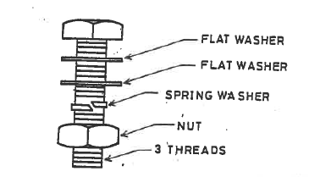

Appendix 2
All components screwed into interior back plates (except red spot fuse holders) are to be as the image with not more than 5 threads through the interior back plate.
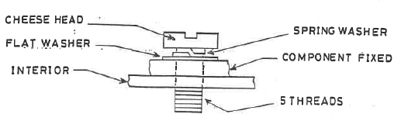
Appendix 3
All red spot fuse holders are to be fixed to the interior back plate using the appropriate screw and a spring washer under the head as per the image with not more than 5 threads through the interior back plate.

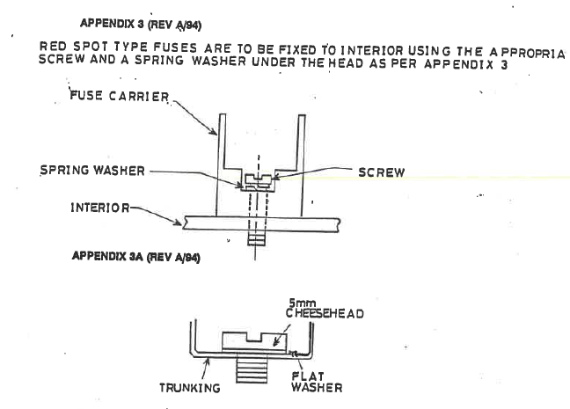
Appendix 4
All trunking is to be fixed to the interior back plate using the appropriate screw and a flat washer under the head as per the image with not more than 5 threads through the interior back plate.
Appendix 5
All din rail and terminal rail must to be fixed to the interior back plate using the appropriate screw and a shakeproof washer under the head as per the image with not more than 5 threads through the interior back plate.
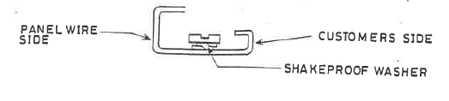
Appendix 6
Tap Size | Drill Size | Self-Tap Size | Drill Size
3mm | 2.5mm | 6 | 2.8
4mm | 3.3mm | 8 | 2.9
5mm | 4.2mm | 10 | 3.4
6mm | 5.1mm
8mm | 6.8mm
10mm | 8.5mm
12mm | 10.3mm

Appendix 7
All cables shall be identified at both ends using matching markers for each electrically distinct circuit. Markings shall read away from the terminal as per the image.
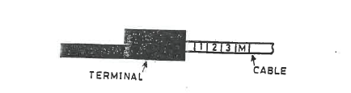

Appendix 8
All control cables up to 6 mm² must be stripped and crimped so that the wire strands protrude 1.5 mm beyond the barrel to ensure strand flare and achieve a dovetail locking effect. The crimped area must finish 1.5 mm below the top of the barrel to maintain the dovetail lock.
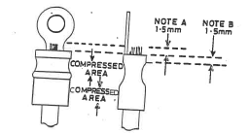

Red crimps should be used on cables up to 1.5mm, blue crimps on 2.5mm cable and yellow crimps on 4mm-6mm cable.

Appendix 9
Larger Power cables must be prepared and crimped as per the guide below taking care not to damage conductors. (Refer to Appendix 10 for number of crimps)

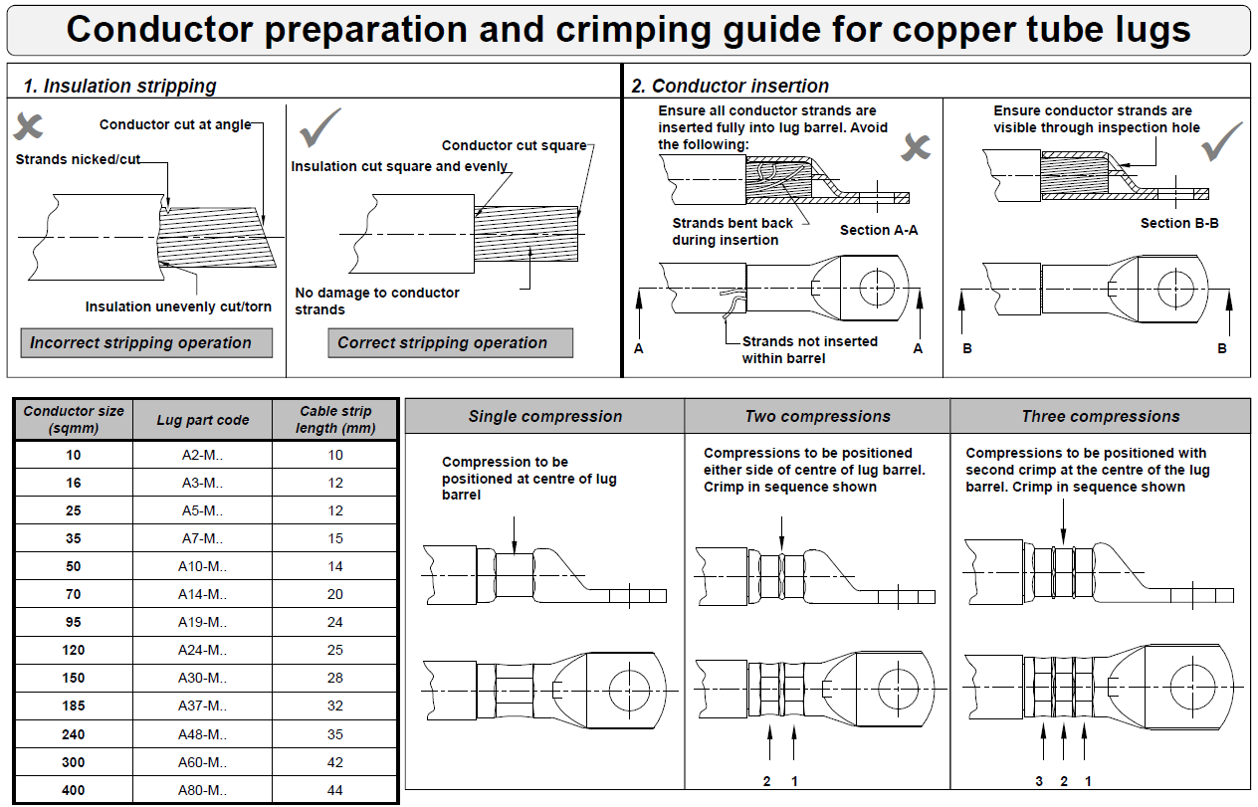
Appendix 10
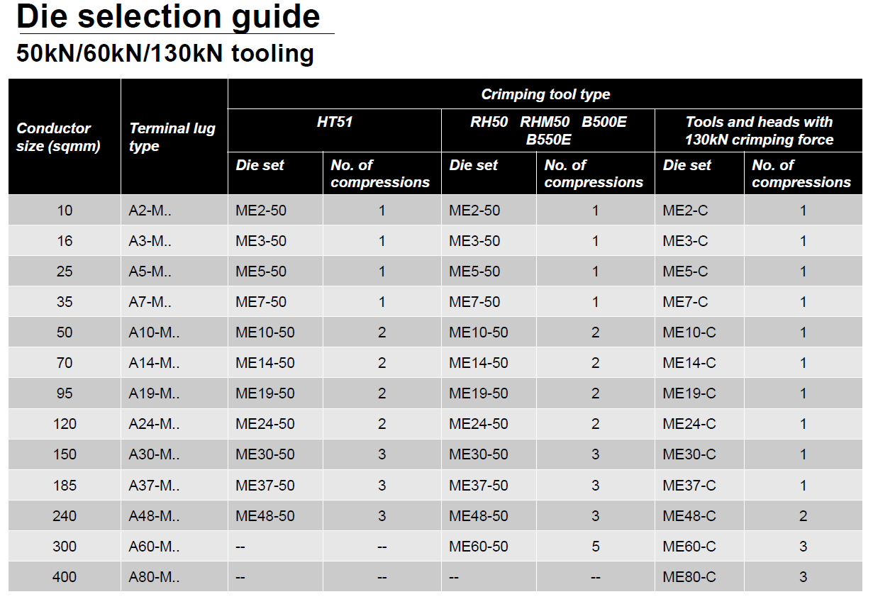
Appendix 11
CABLE SIZE RATINGS

Coil Lead to BS 6195
(Temperature rating 90°C maximum conductor operating temperature)
CABLE SIZE (mm²) | AMPS
1.00 | 12
1.50 | 16
2.50 | 22
4.00 | 29
6.00 | 39
10.00 | 57
16.00 | 76
25.00 | 104
35.00 | 131
50.00 | 162
70.00 | 208
95.00 | 257
120.00 | 305

Coil Lead to BS 6195 Type 4 Category C
(Temperature rating 90°C maximum conductor operating temperature)
CABLE SIZE (mm²) | SINGLE | 2 CABLES GROUPED | 3 CABLES GROUPED
25 | - | - | 115
35 | - | - | 143
50 | 247 | 197 | 172
70 | 318 | 254 | 222
95 | 384 | 307 | 268
120 | 446 | 356 | 312
150 | 513 | 410 | 359
185 | 589 | 471 | 412
240 | 703 | 562 | 492

Appendix 12

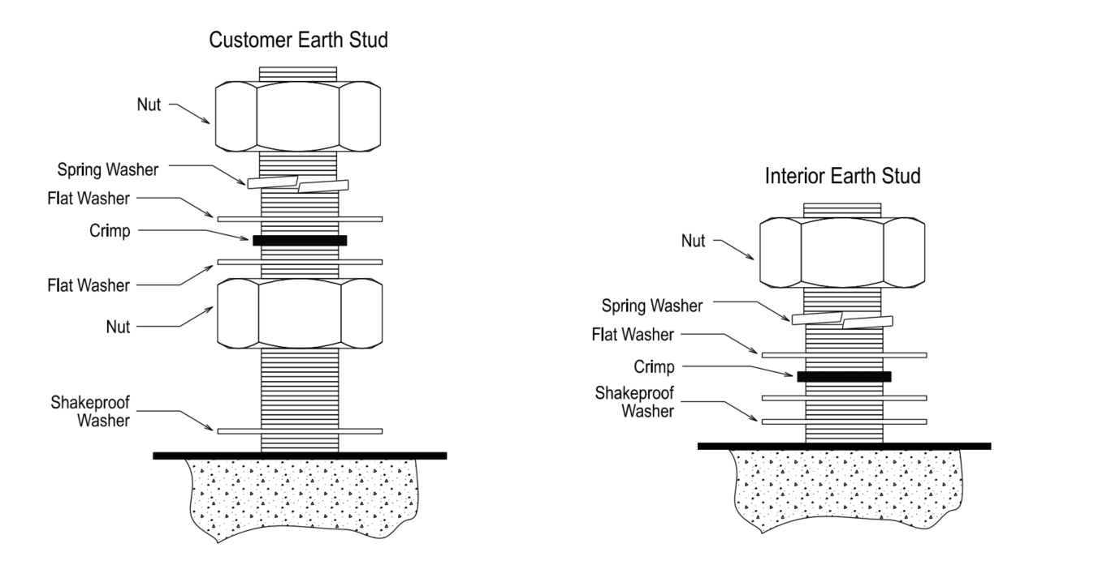

Appendix 13
EARTHING CABLE SIZES

UP TO 100 AMPS - EQUAL TO PHASE CONDUCTOR
101 AMPS TO 200 AMPS - 16mm²
201 AMPS TO 300 AMPS - 25mm²
301 AMPS TO 500 AMPS - 35mm²
501 AMPS TO 800 AMPS - 50mm²
801 AMPS TO 1000 AMPS - 70mm²
1001 AMPS TO 1250 AMPS - 95mm²
1251 AMPS TO 1600 AMPS - 25 x 6.3 COPPER
1601 AMPS TO 2500 AMPS - 30 x 6.3 COPPER
2501 AMPS TO 3200 AMPS - 40 x 6.3 COPPER
Appendix 14
RECOMMENDED BUSBAR CONNECTION TORQUE CHART – AS PER TORQUE SETTINGS FOR BUSBAR BOLTS & WITHDRAWABLE PLUGS / SOCKETS.

NOTE: Busbar bolts MUST be high tensile grade 8.8 steel in all cases. The LV Engineering Manager must be consulted prior to the use of any other grade being used.

Tolerance is + 0, -10%.
Rolla Bolt Settings
Rolla Busbar Bolt Settings
(High Tensile Grade 8.8 Steel)
Bolt Size | N.M | Ft. lbs | A/F Spanner Size
M6 | 8 | 5.9 | 10mm
M8 | 20 | 14.75 | 13mm
M10 | 40 | 29.5 | 17mm
M12 | 70 | 51.6 | 19mm

Rolla Withdrawable Plugs / Sockets Settings
(Silver Plated Brass with Steel / Brass Nuts)
Bolt Size | N.M | Ft. lbs | A/F Spanner Size
M8 | 6-8 | 4.4 – 5.9 | 13mm
M10 | 10 | 7.3 | 17mm
M12 | 25 | 18.4 | 19mm

Standoff insulator with sandwich washer (neoprene) – 13.5nm
Standoff via copper and glass fibre tie bar – 34.0 nm
Shearfab Bolt Settings
Shearfab Busbar Bolt Settings
(High Tensile Grade 8.8 Steel)
Bolt Size | N.M | Ft. lbs | A/F Spanner Size
M6 | 6.5 | 4.8 | 10mm
M8 | 26 | 19.2 | 13mm
M10 switches | 26 | 19.2 | 17mm
M10 copper to copper | 40 | 29.5 | 17mm
M12 | 70 | 51.6 | 19mm

Appendix 15
HDHC COPPER BUSBAR RATINGS

Ratings assume a temperature-rise of 50°C on 35°C Ambient

Busbar Size | Current Ratings (Amp)
 | 1 Bar | 2 Bars | 3 Bars
20 x 2.5 | 235 | 418 | 575
25 x 2.5 | 287 | 510 | 703
40 x 2.5 | 426 | 758 | 1043
50 x 2.5 | 516 | 918 | 1264
63 x 2.5 | 630 | 1121 | 1543
25 x 6.3 | 473 | 842 | 1158
40 x 6.3 | 693 | 1233 | 1698
50 x 6.3 | 832 | 1480 | 1963
63 x 6.3 | 1010 | 1798 | 2383
80 x 6.3 | 1220 | 2098 | 2879
100 x 6.3 | 1465 | 2417 | 3164
150 x 6.3 | 2050 | 3280 | 4141
160 x 6.3 | 2145 | 3432 | 4247
30 x 10 | 815 | 1402 | 1923
50 x 10 | 1060 | 1823 | 2374
63 x 10 | 1260 | 2079 | 2721
100 x 10 | 1800 | 2880 | 3636
125 x 10 | 2150 | 3332 | 4214
150 x 10 | 2340 | 3556 | 4346
160 x 10 | 2620 | 3878 | 4716

Appendix 16
FLEXIBAR CURRENT RATINGS
Ratings assume a temperature-rise of 50°C on 35°C ambient
Size | OEM Part Ref. (EriFlex) | Current rating (Amp)
6 x 20mm x 1mm | 552530 | 413
4 x 24mm x 1mm | 552570 | 416
8 x 24mm x 1mm | 552600 | 606
10 x 24mm x 1mm | 552610 | 716
3 x 32mm x 1mm | 552630 | 430
6 x 32mm x 1mm | 552660 | 640
10 x 32mm x 1mm | 552680 | 930
2 x 40mm x 1mm | 552690 | 406
5 x 40mm x 1mm | 552720 | 680
8 x 40mm x 1mm | 552740 | 930
10 x 40mm x 1mm | 552750 | 1055
3 x 50mm x 1mm | 552760 | 530
4 x 50mm x 1mm | 552770 | 650
5 x 50mm x 1mm | 552780 | 830
8 x 50mm x 1mm | 552800 | 1050
10 x 50mm x 1mm | 552810 | 1245
3 x 63mm x 1mm | 552820 | 603
4 x 63mm x 1mm | 552830 | 763
5 x 63mm x 1mm | 552840 | 920
6 x 63mm x 1mm | 552850 | 1085
8 x 63mm x 1mm | 552860 | 1245
5 x 80mm x 1mm | 552900 | 1050
6 x 80mm x 1mm | 552910 | 1230
8 x 80mm x 1mm | 552920 | 1430
4 x 100mm x 1mm | 552940 | 1093
5 x 100mm x 1mm | 552950 | 1235
8 x 100mm x 1mm | 552970 | 1625
12 x 100mm x 1mm | 552990 | 1890

